

**2018 Banyan Tree School of Yoga**

**200 Hour Teacher Training Course**

**

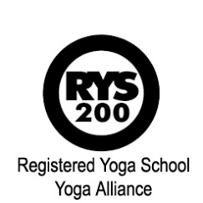

**Please complete the application form below to apply.**

**Banyan Tree School of Yoga Application Form**

***NB – All applicants who are not students of the tutors, are required to attend a class and/or have a short discussion, prior to applying (To arrange an interview telephone Stuart 0790 463 9599 or email*** [***stumailalex@gmail.com***](mailto:stumailalex@gmail.com)***.***

Name:

Address:

Contact No.

Email:

Name of Main Teacher:

No. of Years Practice:

Referred By:

Limiting Conditions? None

**Enclosures**

* I enclose deposit of £1000.00 (made payable to ***Banyan Tree Training***) **OR**
* I enclose full (discounted) payment of £1850.00 **OR**
* I have made payment by BACS to

Account Number: 63866068 Sort Code: 20-51-01

I have read and understood the guidance notes. I accept all the conditions relating to

payment and the refund policy. I have no impediment (medical or otherwise) to prevent me undertaking this course.

Signed:

Print Name:

Please return completed form, with all payments and enclosures to –

[stumailalex@gmail.com](mailto:stumailalex@gmail.com) OR post to:

***Stuart Alexander***

***Yoga Hub Liverpool, 21 Old Hall Street,First Floor,Liverpool, L3 9BS***

After booking is received you will receive your confirmation details.